**NVIDIA And AMD Stock Price Predictions and Comparisons**

**Time Series Analysis for Business Forecasting**

**CONTENTS**

|  |  |  |
| --- | --- | --- |
| 1 | Introduction | 2 |
| 2 | Process | 4 |
| 3 | Data Source | 5 |
| 4 | Investment Analysis | 6 |
| 5 | Model building And Forecasting | 7 |
| 6 | Outliers | 20 |
| 7 | Conclusion | 20 |
| 8 | References | 21 |

**INTRODUCTION:**

**NVIDIA (NASDAQ: NVDA)**

NVIDIA's reputation in **high-performance gaming and graphics cards**precedes it. Their GPUs are the backbone of many modern gaming consoles and PCs, delivering top-notch graphics and smooth gameplay experiences. However, their influence extends beyond gaming. NVIDIA's chips are crucial in machine learning and artificial intelligence, powering various applications from autonomous vehicles to medical research. It is impressive how one company can leave such a profound mark on entertainment and cutting-edge technology..

**AMD (NASDAQ: AMD)**

AMD has carved out its niche in the market, focusing**on desktop and laptop processors**, along with gaming graphics cards. The Ryzen processors, in particular, have garnered attention for their exceptional performance-to-price ratio. This balance between cost and quality has made them popular among users who want high performance without breaking the bank. AMD's dedication to providing competitive options in both processor and graphics card sectors has contributed significantly to the diversity and affordability of hardware options available to consumers.

**Why Nvidia and AMD?**

**NVIDIA (NVDA) and AMD** are two tech giants in the market of **graphics accelerators and graphics cards** that are having a fierce battle in 2024.

 The rivalry between NVIDIA and AMD is a constant source of excitement (Hot topic) in the tech community. Both companies are **powerhouses in the GPU market**, constantly pushing the boundaries of performance and innovation. GPUs they create for graphic applications like games, deep computational problems of Data Science and Machine Learning, and computational physics. New versions of **AMD Radeon graphics cards** have entered the market this year, ready to go head-to-head with **NVIDIA’s RTX accelerators**.

**Factors affecting stock prices of NVIDIA vs. AMD:**

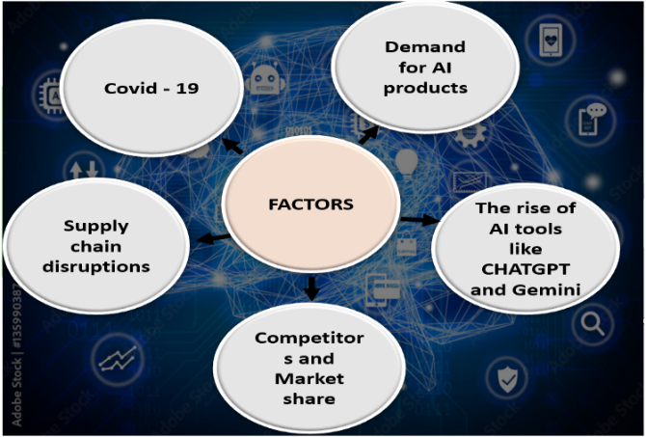

**Covid – 19:**

The COVID-19 pandemic had a **notable effect** on Nvidia's stock price. In the initial months, demand for Nvidia's products soared as people globally had to stay home due to lockdowns. With the rise of remote work and gaming, there was a surge in **the purchase of high-end GPUs for desktops and gaming**. Additionally, a **trend of Bitcoin mining** required high-end processors, further boosting demand for Nvidia's products. This led to a sharp increase in Nvidia's stock price, which **doubled in value between March and December of 2020.**

**The rise of AI tools like CHATGPT and Gemini:**

**OpenAI trained ChatGPT**, using **Nvidia's GPUs** (Graphics et al.) as part of its underlying infrastructure. Nvidia's powerful GPUs played a crucial role in training large language models like ChatGPT, enabling us to process vast amounts of data efficiently and achieve remarkable language understanding and generation capabilities.

**Demand for AI products:**

The demand for **AI products** has significantly contributed to Nvidia's and AMD's stock prices. AI is a rapidly growing field that relies heavily on specialized hardware, such as the GPUs produced by Nvidia and AMD. As businesses and industries across various sectors increasingly **adopt AI technologies for tasks like machine learning, data analysis, and automation, the demand for high-performance GPUs has surged.** This increased demand not only bolsters the revenue of both companies but also positively impacts their stock prices as investors recognize the growth potential in the AI market.

**Supply chain disruptions:**

Like other tech companies, Nvidia faces challenges from **geopolitical issues**affecting the chip business. The U.S. government's sales regulations for specific markets like China and the Middle East can impact Nvidia's business despite its efforts to comply. Additionally, **tensions between Taiwan and China threaten Nvidia's supply chain**, particularly with its principal partner, TSMC. These factors add complexity and uncertainty to Nvidia's operations.

**NVIDIA vs. AMD fierce competition**

As technology progresses, NVIDIA and AMD continue their fierce competition, promising consumers and professionals even more powerful GPUs. **This rivalry ensures** exciting **gaming, design, AI advancements, and more**. By understanding the strengths of each company's products, Any individual can make informed choices that suit your needs.

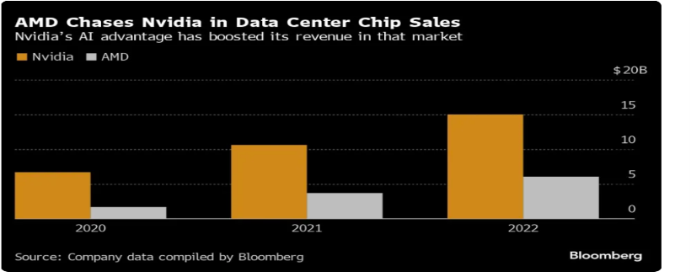 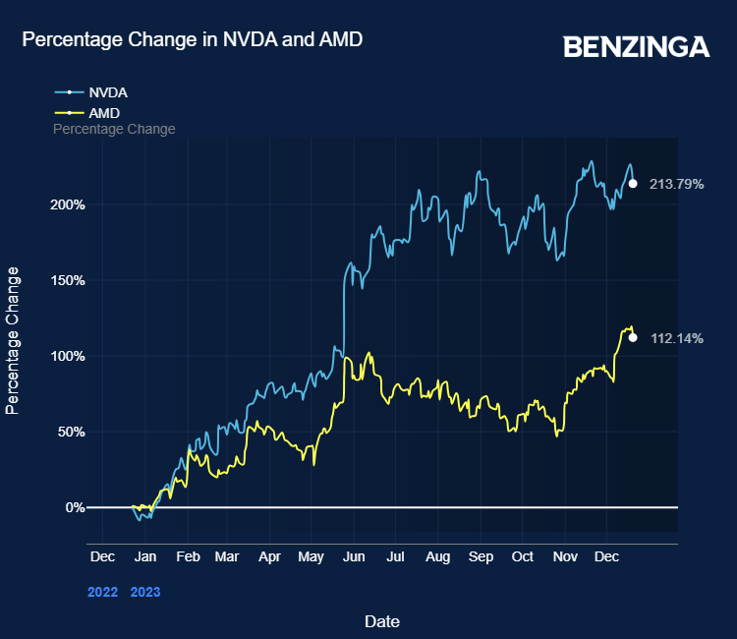

•NVIDIA and AMD often **respond similarly to market fluctuations**and industry trends because they operate within the same sector.

•**Major shifts**, such as the rise in **artificial intelligence advantage or consumer demand**, tend to impact both companies.

•Tracking **news** through an economic calendar is **indeed a valuable tool**for investors and analysts to understand how events **correlate**with changes in stock prices for both **NVIDIA and AMD**

**“Consider when Nvidia made the first shift in 2005... if you invested $1,000, you would have $537,692! *” - Travis Hoium, The Motley Fool** (Motley Fool Stock Advisor analyst)

**PROCESS**

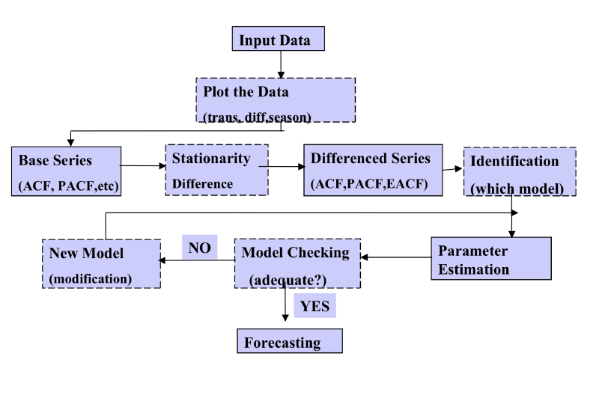

**DATA SOURCE**

Link: https://finance.yahoo.com

**NVIDIA Dataset:**

The NVIDIA dataset comprises 10 years from 2014 to 2024 of stock price history, containing

columns date, open, high, low, close, and volume. The dataset encompasses 2576

rows, with a daily frequency of observations.

**AMD Dataset:**

The AMD dataset comprises 10 years from 2014 to 2024 of stock price history, containing

columns date, open, high, low, close, and volume. The dataset encompasses 2576

rows, with a daily frequency of observations.

**Column Description:**

**Date**: This column records the specific day of trading. It's usually in a format such as YYYY-MM-DD. This helps you identify when the trading occurred.

**Open**: Stock price at the beginning of the trading day. It provides a starting point for the day's trading and is useful for seeing how the stock's price begins the day compared to previous days.

**High**: Highest price the stock traded during the trading day. This can indicate moments when the stock was in high demand.

**Low**: Stock's lowest price during the trading day. This can indicate moments of lower demand or sell-offs.

**Close**: Price of the stock at the end of the trading day. It's often used as the standard price when comparing day-to-day performance, as it represents the final valuation for that day.

**Volume**: Provides information on how many shares of the stock were traded during the day. High volume can indicate a high level of interest in the stock, either buying or selling, while low volume might suggest less interest or stability.

These columns together provide a comprehensive overview of the stock's daily trading behaviour, helping analysts and investors understand market trends, stock volatility, and trading patterns.

**Investment Analysis for NVDA and AMD**

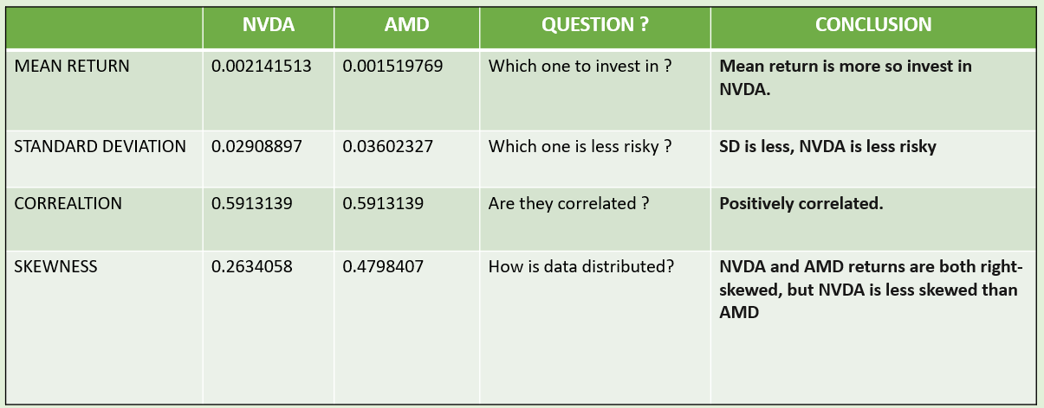

**Which one to invest in?**

NVIDIA exhibits a higher average daily return compared to AMD. This suggests a higher potential for profit with NVIDIA, making it the preferred investment choice based on return performance.

**Which one is less risky?**

NVIDIA presents a lower standard deviation than AMD, indicating less volatility and hence lower risk. Investors seeking stability might prefer NVIDIA, as it demonstrates less fluctuation in daily returns.

**Are they correlated?**

There is a moderate positive correlation between NVIDIA and AMD returns, indicating that the stocks typically move in tandem to a certain degree. This correlation is significant for portfolio diversification; investing in both may not provide significant risk mitigation benefits in this context.

**How is data distributed?**

Both stocks show a positive skewness, implying more frequent small gains and fewer but larger gains. NVIDIA’s return distribution is less skewed than AMD’s, suggesting a distribution closer to normal and potentially indicating more predictable performance.

Final Recommendation: Considering the higher mean return and lower volatility, NVIDIA is recommended over AMD for investment. Its return distribution also shows less skewness, which might appeal to investors looking for more predictable returns. The positive correlation between NVIDIA and AMD should be considered when constructing a diversified portfolio, as similar movements might not provide extensive risk diversification benefits.

**MODEL BUILDING**

**NVIDIA**

The initial plot shows a significant upward trend in NVIDIA's stock price over the analyzed period, with notable growth, particularly after 2020. The upward trend points towards the non-constant mean and variance showing non-stationarity. The decay in the ACF is very gradual, which typically signals a non-stationary time series. PACF plot showing a sharp drop to near zero after the first lag and remains between the confidence bound across further lags.

**Dickey-Fuller unit-root test for stationary:**

H0: The series has a unit root (the data is non-stationary).

Ha: The series has no unit root (the data is stationary).

**As the p-value is greater than 0.05, we can’t reject the Null hypothesis suggesting that the data is non-stationary.**

**Figure 1 : Time series plot ACF and PACF of original data.**

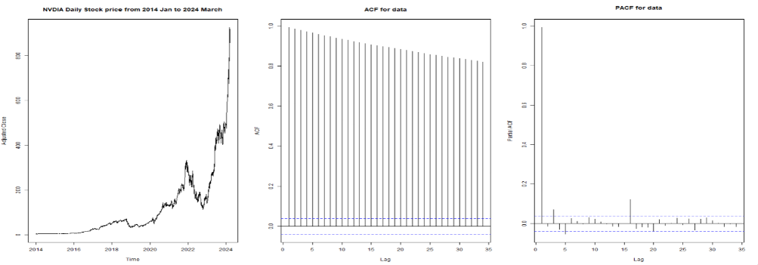

**Figure 2 : Dickey-Fuller unit-root test for stationary.**

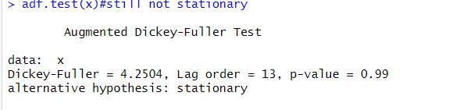

Upon conducting transformations on the original time series data, including logarithmic scaling and differencing to address issues of non-stationarity, the resultant plot exhibits a consistent mean and variance, indicative of stationarity. The Autocorrelation Function (ACF) plot reveals significant spikes at certain lags, suggesting the presence of autocorrelation at these intervals. This pattern may indicate underlying periodic or seasonal effects within the data. Furthermore, the Partial Autocorrelation Function (PACF) plot highlights correlations that are not accounted for by earlier lags, thereby aiding in the identification of the appropriate order for an autoregressive model. These analyses are crucial for developing a robust forecasting model that accurately captures the dynamics of the time series.

**Dickey-Fuller unit-root test for stationary:**

H0: The series has a unit root (the data is non-stationary).

Ha: The series has no unit root (the data is stationary).

**As the p-value is smaller than 0.05, we can reject the Null hypothesis suggesting that the data is stationary.**

**Figure 3: Time series plot, ACF and PACF of data after transformation.**

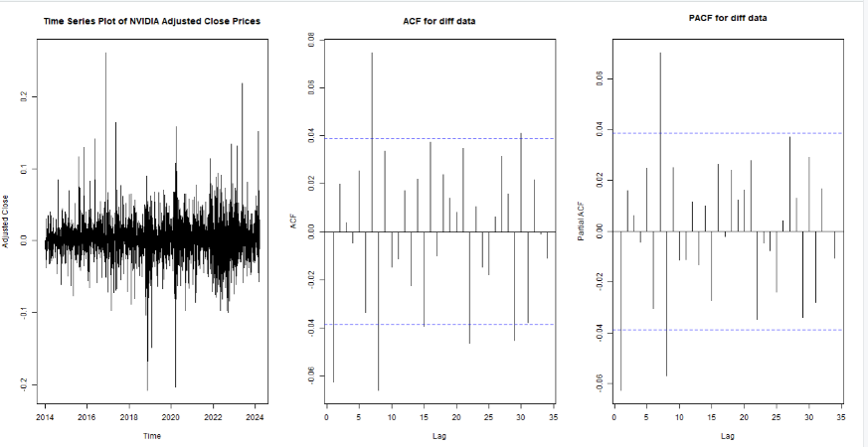

**Figure 4: Dickey-Fuller unit-root test for stationary.**

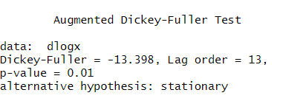

**Figure 5: Seasonality Plot**

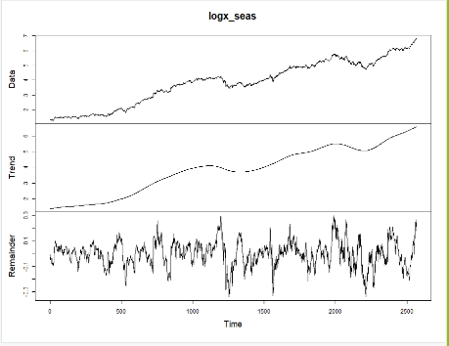After conducting the seasonality test, it was concluded that there are no seasonal patterns present in the dataset. The plots indicate that once the overall trend is removed, there isn't a clear repeating pattern at regular intervals in the remainder component.

The plot shows no clear repeating patterns in the residuals, suggesting a lack of strong seasonality in the data.

Upon examining the Extended Autocorrelation Function (EACF) graph and the Partial Autocorrelation Function (PACF) graph, we selected the Moving Average (MA) model of order 3 and the Autoregressive (AR) model of order 8 for further analysis.

**Figure 6: EACF and PACF**

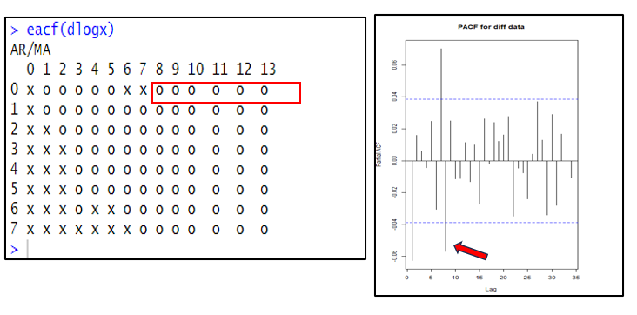

**AR(8) Model:** We initially fitted an Autoregressive model of order 8 (AR(8)). During this process, we assessed the significance of each term. Terms that were found to be statistically non-significant were omitted from the model to simplify the model. We conducted a comparison between the original AR(8) model and the fixed model.

The fixed AR (8) model, which excluded non-significant terms, demonstrated a lower AIC of **-10892.92** compared to the original model which was **-10886.64**. Consequently, we selected this revised model for further analysis. A stationarity check was performed using polyroot test with the revised AR (8) model and the test confirmed that the model is stationary, indicating that its statistical properties do not vary over time and it is suitable for forecasting.

**Figure 7: Estimated Model of AR(8) which excluded non-significant terms**

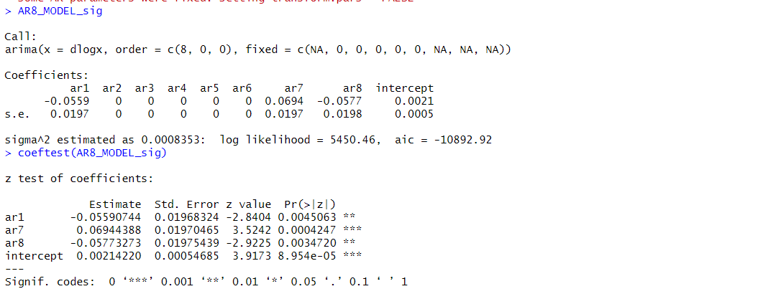

**MA (8) Model:** We fitted a Moving Average model of order 8. During the fitting process, we evaluated the significance of each term individually. Non-significant terms, which did not contribute significantly to the model's performance, were removed. After adjusting the initial MA(8) model by removing non-significant terms, we compared the AIC values of the original and the revised models.

The modified MA(8) model, with non-significant terms excluded, exhibited a lower AIC value of -10889.96 compared to the original model which was -10882.9. This indicated that the fixed model was more effective in explaining the variability of the data with fewer parameters. Consequently, we selected the fixed MA(8) model for further application and analysis. We didn’t perform a stationary check as MA models are Always stationary.

**Figure 8: Estimated Model of MA(8) which excluded non-significant terms**

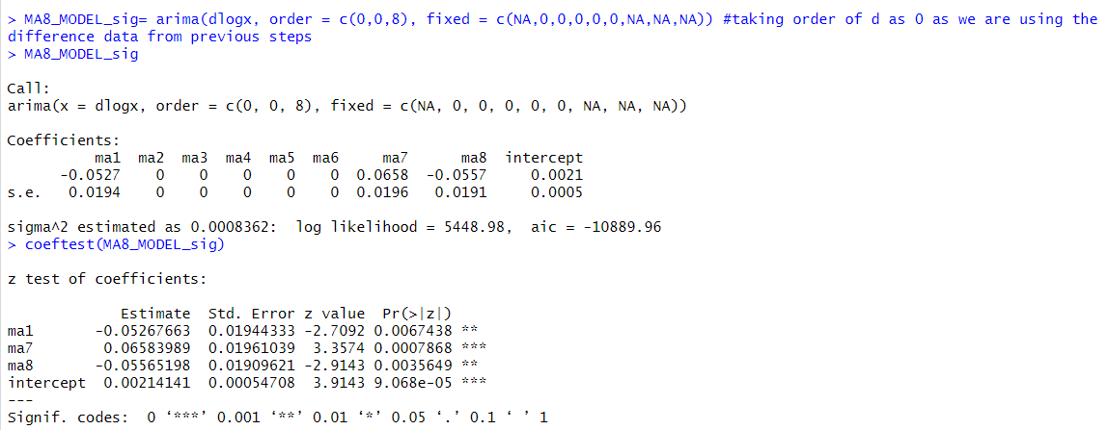

**Figure 9: AIC and Rolling Forecasting comparision of fixed AR(8) and MA(8) model.**

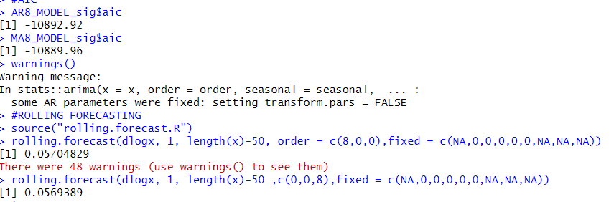

For forecasting, we conducted a comparative analysis between fixed MA(8) and AR(8) models, This comparison involved evaluating both models based on their AIC values and performing a rolling forecasting error test. The AIC comparison aimed to identify the model that optimally balances model complexity and goodness of fit. The rolling forecasting error test assessed the predictive accuracy of each model over a series of time steps.

Based on the results, the AR(8) model was chosen for further use in forecasting. This decision was driven by the AR(8) model's lower AIC value which is **-10892.92,** indicating a better model fit with fewer parameters, despite there being minimal difference in the rolling forecasting error between the two models. This approach ensures that the selected model not only fits the historical data well but also provides reliable predictions moving forward.

**Residuals Plot:** The plot shows that the residuals seem to be randomly distributed around the zero line, which would indicate that the model has adequately captured the information in the data.

ACF and PACF of residuals show that there is no significant autocorrelation at all lag everything lies within the confidence band

**Box-Ljung Test:**. The p-value is 0.9347, indicating no autocorrelation and the residuals are **white.**

The **Standardized Residuals Plot** displays a time series of standardized residuals, which ideally resemble 'white noise' indicating constant variance and no pattern, validating the assumptions of homoscedasticity and the absence of autocorrelation. The ACF of the Residuals graph, displaying autocorrelation coefficients within the confidence interval, suggests no significant autocorrelation, confirming the randomness of residuals. Additionally, the p-values for the Ljung-Box statistic, presented at various lags, are all well above 0.05, indicating the absence of significant autocorrelations in the data, further supporting the residuals' randomness.

Both collectively suggest that the AR(8) model has performed adequately, capturing the essential dynamics in the data without leaving patterns in the residuals. This supports the model's suitability for forecasting as it meets key assumptions needed for reliable predictions.

**Figure 10: Residual Analysis for selected AR(8) model**

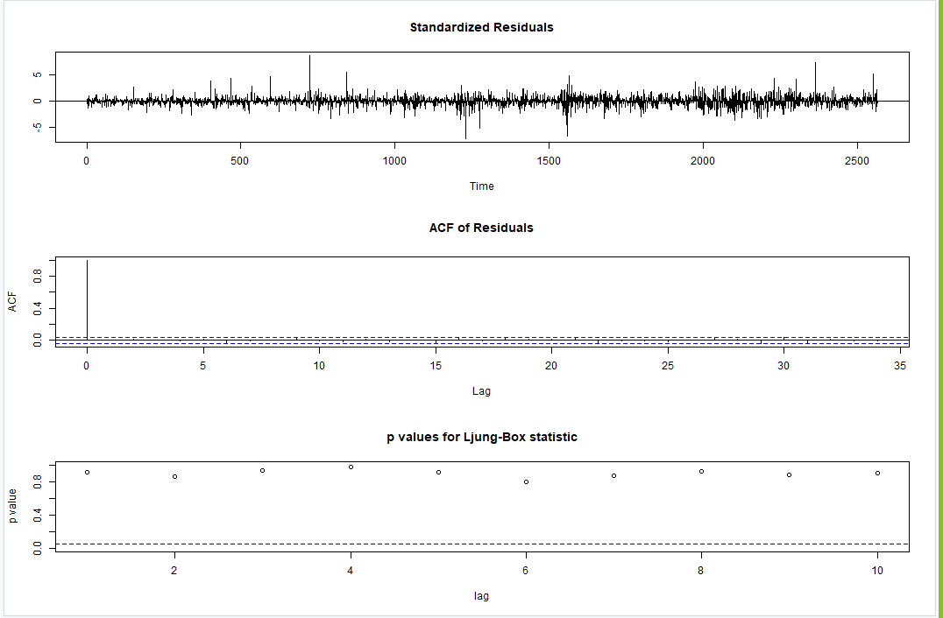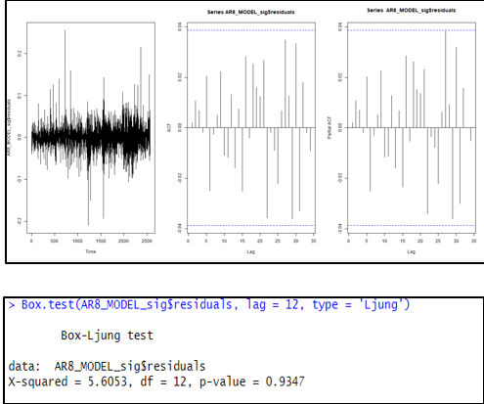

**Figure 11: Predicted and 95% confidence interval values**

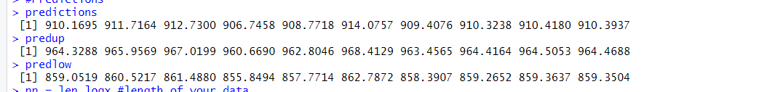

**Figure 12: Forecast for Nvidia**

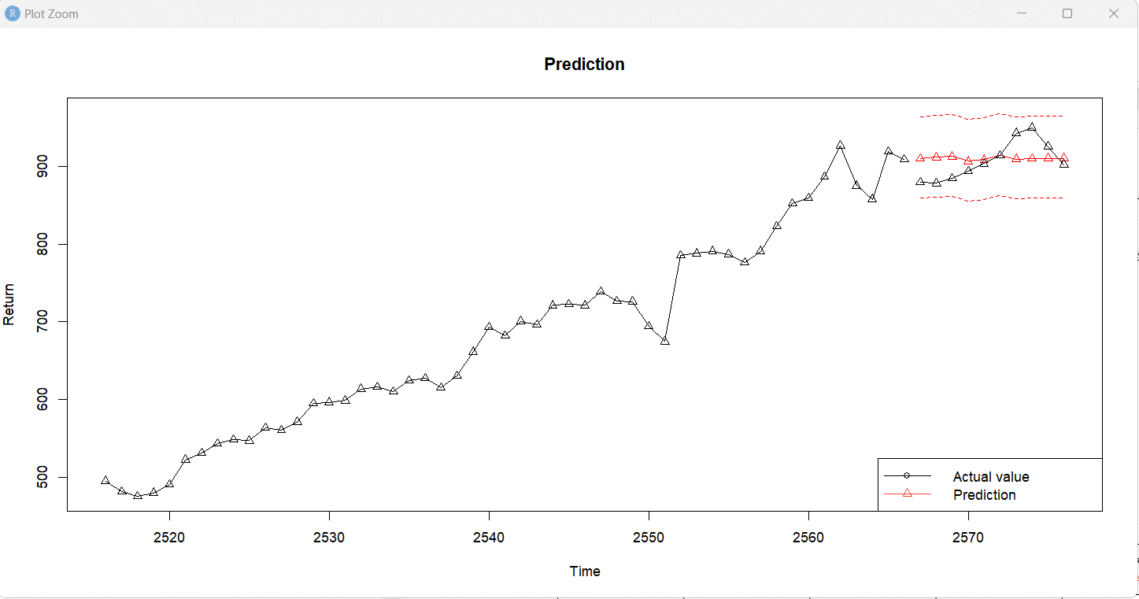

We conducted a 10-step ahead forecasting analysis, as illustrated in the plot. This plot presents the last 50 actual values in black, against the forecasted values depicted in red. It is observed that while our model initially aligns with some of the actual values, the predictions tend to flatten subsequently. As a result, the forecasted values do not closely approximate the actual data points beyond a certain time point. This divergence suggests potential limitations in the model's ability to accurately capture and extend the underlying data trends in the latter part of the forecasting period.

**AMD**

The first graph shows AMD's daily stock price from 2014 to 2024, highlighting a significant upward trend starting around 2020, indicating growth and suggesting the data might not be stationary. The ACF plot shows a slow decline in correlations as the lag increases, typical of non-stationary data. The PACF plot sharply drops after the first lag, suggesting that only the immediate past value significantly predicts future values, typical of data well modelled by a first-order autoregressive process.

**Dickey-Fuller unit-root test for stationary:**

H0: The series has a unit root (the data is non-stationary).

Ha: The series has no unit root (the data is stationary).

**As the p-value is greater than 0.05, we can’t reject the Null hypothesis suggesting that the data is non-stationary.**

**Figure 13: Time series plot ACF and PACF of original data.**

**Figure 14 : Dickey-Fuller unit-root test for stationary.**

After applying logarithmic scaling and differencing to the original time series data to address non-stationarity, the resulting plot shows a consistent mean and variance, indicating stationarity. The Autocorrelation Function (ACF) plot displays prominent peaks at specific lags, indicating the existence of autocorrelation at those time intervals. This pattern suggests the presence of periodic or seasonal impacts within the data. Moreover, the Partial Autocorrelation Function (PACF) plot specifically reveals correlations that are not explained by previous time lags. This helps determine the optimal sequence for an autoregressive model. These investigations are essential for constructing a strong forecasting model that precisely reflects the dynamics of the time series.

**Dickey-Fuller unit-root test for stationary:**

H0: The series has a unit root (the data is non-stationary).

Ha: The series has no unit root (the data is stationary).

**As the p-value is smaller than 0.05, we can reject the Null hypothesis suggesting that the data is stationary.**

**Figure 15: Time series plot, ACF and PACF of data after transformation.**

**Figure 16: Dickey-Fuller unit-root test for stationary.**

**Figure 17: Seasonality Plot**

Upon performing the seasonality test, it was determined that the dataset does not exhibit any seasonal patterns. The charts demonstrate that after eliminating the general trend, there is no discernible recurring pattern at consistent intervals in the residual component.  
The residuals exhibit no discernible recurring patterns in the plot, indicating a dearth of significant seasonality in the data. 

Upon examining the Extended Autocorrelation Function (EACF) graph, we selected the MA(3), MA(1) and ARMA(1,2) models for further analysis.

**Figure 18: EACF**

**MA(1) Model:** **:**

We fitted a Moving Average model of order 1 and evaluated the significance of the term during the model fitting process. It was found that there were no non-significant terms, so the MA(1) model remained unchanged with an AIC value of -9771.7. This indicates that the model was already optimal for explaining the variability of the data without the need for adjustments. Consequently, the MA(1) model was selected for further application and analysis. We did not perform a stationarity check as MA models are inherently stationary.

**Figure 19: Estimated Model of MA(1)**

**MA(3) Model:**

We fitted a Moving Average model of order 3 and evaluated the significance of the term during the model fitting process. It was found that there were no non-significant terms, so the MA(3) model remained unchanged with an AIC value of -9776.81. This indicates that the model was already optimal for explaining the variability of the data without the need for adjustments. Consequently, the MA(3) model was selected for further application and analysis

**Figure 20: Estimated Model of MA(3)**

**ARMA(1,2) Model:**

We fitted an ARMA(1,2) model and evaluated the significance of its terms. After dropping the non-significant terms, we compared the AIC values before and after the adjustments. The initial AIC was -9776.53, and it improved slightly to -9776.61 after refining the model. This indicated that the adjusted model was more effective in explaining the data with fewer parameters. We chose to proceed with this fixed ARMA(1,2) model because of its lower AIC value. Additionally, we confirmed that the model is stationary and not redundant, ensuring its appropriateness for further analysis.

**Figure 21: Estimated Model of ARMA(1,2)**

**Figure 22: AIC and Rolling Forecasting comparison of fixed MA(1), MA(3) and ARMA(1,2) model.**

For forecasting, we conducted a comparative analysis between fixed MA(1), MA(3) and ARMA(1,2) models, This comparison involved evaluating all models based on their AIC values and performing a rolling forecasting error test. The AIC comparison aimed to identify the model that optimally balances model complexity and goodness of fit. The rolling forecasting error test assessed the predictive accuracy of each model over a series of time steps.

Based on the results, the ARMA(1,2) model was chosen for further use in forecasting. This decision was driven by the ARMA(1,2) model's lower AIC value which is **-9776.61,** indicating a better model fit with fewer parameters, despite there being minimal difference in the rolling forecasting error between the three models. This approach ensures that the selected model not only fits the historical data well but also provides reliable predictions moving forward.

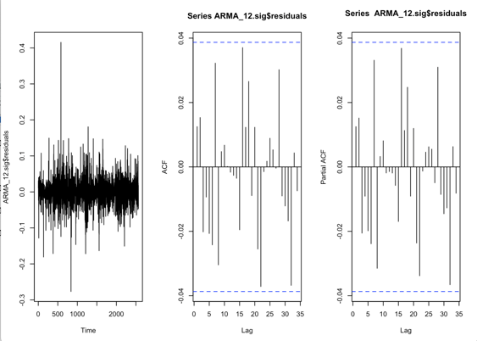**Figure 23: Residual Analysis for selected ARMA(1,2) model**

**Residuals Plot:** The plot shows that the residuals seem to be randomly distributed around the zero line, which would indicate that the model has adequately captured the information in the data.

ACF and PACF of residuals show that there is no significant autocorrelation at all lag everything lies within the confidence band.

**Box-Ljung Test:**. The p-value is 0.6046, indicating no autocorrelation and the residuals are **white.**

The **Standardized Residuals Plot** shows a sequence of standardized residuals over time. These residuals shows ideal exhibit characteristics of 'white noise', signifying consistent variability and no discernible pattern. This validates the assumptions of homoscedasticity (constant variance) and the lack of autocorrelation. The Autocorrelation Function (ACF) graph of the residuals, which shows the autocorrelation coefficients falling inside the confidence range, indicates the absence of significant autocorrelation. This confirms that the residuals are random. In addition, the p-values for the Ljung-Box statistic, calculated at different time delays, are all greater than 0.05. This suggests that there are no significant autocorrelations in the data, providing further evidence of the randomness of the residuals.

Both collectively suggest that the ARMA(1,2) model has performed adequately, capturing the essential dynamics in the data without leaving patterns in the residuals. This supports the model's suitability for forecasting as it meets key assumptions needed for reliable predictions.

**Figure 25: Forecast for AMD**

**Figure 24: Predicted and 95% confidence interval values**

We performed a 10-step ahead forecasting analysis, as depicted in the plot. This map displays the most recent 50 observed values in black, juxtaposed with the projected values represented in red. It has been seen that although our model initially corresponds with some real values, the predictions gradually become less varied and more uniform. Consequently, the predicted values do not closely resemble the actual data points beyond a specific time. This discrepancy indicates possible constraints in the model's capacity to precisely collect and project the underlying data patterns in the later portion of the forecasted timeframe.

**OUTLIERS**

**Table 1: Outlier Count for Nvidia and AMD.**

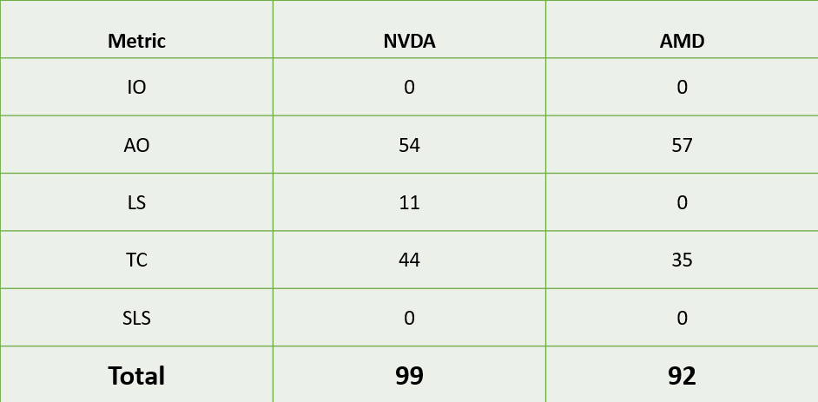

In response to the forecasted values significantly diverging from the actual observations, we considered conducting an intervention analysis to identify and adjust for discrepancies. To this end, we performed an outlier analysis for Nvidia and AMD. Outliers, defined as data points that deviate markedly from the rest of the data, play a critical role in data analysis, impacting the accuracy of modeling and forecasting. We focused on several outliers, including Additive Outliers, Temporary Changes, Level Shifts, Innovational Outliers, and Seasonal Level Shifts.

Our analysis revealed that **Nvidia has 99 outliers** across the metrics evaluated, while **AMD has a slightly lower count of 92**.

Given the high number of outliers, conducting a thorough intervention analysis presents substantial challenges. Numerous outliers can complicate the interpretation and adjustment processes, making it difficult to analyse each individually. So we decided not to go ahead with the intervention analysis.

**CONCLUSION**

In conclusion, the forecasting model started strong but faced challenges. The market reacts rapidly to new information, making it difficult to keep up. Looking at the forecast plots, one will notice that predicted stock prices do not closely align with the actual prices. Therefore, despite our best efforts, these factors make achieving precise predictions somewhat challenging.

**Limited Past Influences**: Past data may not always adequately predict future stock prices due to unpredictable market conditions and influencing factors. The semiconductor sector, where NVIDIA and AMD operate, is especially tricky due to sudden changes in regulations, shifts in global supply chains, and the surge in AI demand exacerbated by COVID-19.

**Smart Market:** According to this theory, beating the market consistently through technical or fundamental analysis can be challenging because new information is rapidly incorporated into stock prices.

**Random Price Movement:** This concept is related to the random walk theory, which posits that stock price changes are random and unpredictable. The theory argues that a stock price's past movement or trend cannot reliably predict its future movement, making it difficult to achieve consistent returns through prediction.

 Despite these challenges, NVIDIA and AMD have shown impressive growth in their stock prices from 2014 to 2024. **NVIDIA** surged from **$39 to $902.58,** while **AMD** climbed from **$3.7 to $179.5**. This indicates the potential for good returns by investing in either company. With technology continuing to advance, investing in NVIDIA and AMD could **yield significant long-term gains.** However, it is crucial to carefully weigh these factors before making any investment decisions.

**REFERENCES**

1. Lecture Notes MIS 748 Time Series Analysis for Business Forecasting by   
   Dr. Xialu Liu <https://sdsu.instructure.com/courses/150554/pages/lecture-notes?module_item_id=3655125>
2. NVIDIA - 25 Year Stock Price History. Macrotrends.net. <https://www.macrotrends.net/stocks/charts/NVDA/nvidia/stock-price-history#:~:text=The%20all%2Dtime%20high%20NVIDIA,above%20the%20current%20share%20price>
3. NVIDIA Corporation (NVDA). Finance.Yahoo.com. <https://finance.yahoo.com/quote/NVDA?.tsrc=fin-srch>
4. Advanced Micro Devices, Inc. (AMD). Finance.Yahoo.com. <https://finance.yahoo.com/quote/AMD?.tsrc=fin-srch>
5. Hoium, T. (2024, April 30). This Streaming Stock Is in Huge Trouble. Finance.Yahoo.com. <https://finance.yahoo.com/news/streaming-stock-huge-trouble-220753874.html>
6. Hoium, T. (2023, March 22). Nvidia’s outrageous pricing strategy is exactly why we need AMD and Intel. www.Digitaltrends.com. [https://www.digitaltrends.com/computing/nvidias-pricing-strategy-is-why-we-need-amd-andintel/#:~:text=GPUs%20have%20been%20getting%20pricier,Jacob%20Roach%20/%20Digital%20Trends](https://www.digitaltrends.com/computing/nvidias-pricing-strategy-is-why-we-need-amd-and-intel/#:~:text=GPUs%20have%20been%20getting%20pricier,Jacob%20Roach%20/%20Digital%20Trends)
7. Tatevosian, P. (2024, April 3). Nvidia Stock and AMD Stock: You Won't Believe My Shocking Conclusion. Www.Fool.com. <https://www.fool.com/investing/2024/04/03/nvidia-stock-and-amd-stock-you-wont-believe-my-sho/>
8. Rexaline, S. (2020, February 19). Why AMD's Coronavirus Impact Could Be Worse Than Intel, Nvidia. Finance.Yahoo.com. <https://finance.yahoo.com/news/why-amds-coronavirus-impact-could-190000795.html>